|  |  |  |  |
| --- | --- | --- | --- |
| 1 | | 888 | |
| **NUMERO DE FRONTERAS** | | **ENERGIA AGREGADA** | |
|  | | | |
| 5,258,341 | 85 | | 181,340 |
| INGRESO 2020 | DÍAS CERTIFICADOS 2020 | | ENERGIA RESPALDADA 2020 |
|  | | | |
| 1,796,107 | 88 | | 78,020 |
| INGRESO 2021 | DÍAS CERTIFICADOS 2021 | | ENERGIA RESPALDADA 2021 |

**HISTORICO REINTEGRO DDV**

|  |  |  |
| --- | --- | --- |
|  | **2020** | **2021** |
| **ENE** | 1,451.78 | 356.84 |
| **FEB** | 1,944.03 | 500.39 |
| **MAR** | 1,439.93 | 195.62 |
| **ABR** | - | - |
| **MAY** | - | 487.45 |
| **JUN** | - | 217.12 |
| **JUL** | 300.78 | 38.69 |
| **AGO** | 102.43 | - |
| **SEP** | - | - |
| **OCT** | - | - |
| **NOV** | - | - |
| **DIC** | 19.39 | - |

**Los valores de la tabla están en miles de COP**



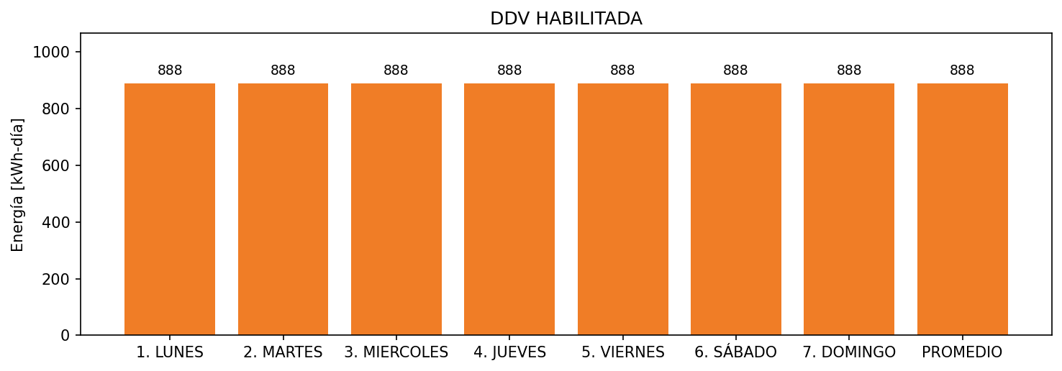

|  |  |  |  |  |  |  |  |  |  |
| --- | --- | --- | --- | --- | --- | --- | --- | --- | --- |
| **FRONTERA** | **COD SIC** | **FRT DDV** | **TIPO DDV** | **PROMEDIO** | **PRÓXIMA ACTUALIZACIÓN** | **MARGEN DE ERROR** | **ÚLTIMA PRUEBA DDV** | **DÍAS PARTICIPACIÓN** | **FECHA REFERENCIA PRÓXIMA PRUEBA DDV** |
| CENTRO EMPRESARIAL BUENAVISTA | Frt29185 | Frt36038 | LBC | 888 | 2022-01-28 | 3,55 | 2020-12-13 | 88.0 | 2021-12-18 |